Case Study: How Can a Wellness Technology Company (Bellabeat) Play It Smart?

(By: Sourabh Kumar)

Introduction: Bellabeat, a high-tech manufacturer of health-focused products for women. Bellabeat is a successful company in the global smart device market. Urška Sršen, cofounder and Chief Creative Officer of Bellabeat, believes that analyzing smart device fitness data could help unlock new growth opportunities for the company. Bellabeat carries products such as: -

* Bellabeat app: - The Bellabeat app provides users with health data related to their activity, sleep, stress, menstrual cycle, and mindfulness habits. This data can help users better understand their current habits and make healthy decisions. The Bellabeat app connects to their line of smart wellness products.
* Leaf: Bellabeat’s classic wellness tracker can be worn as a bracelet, necklace, or clip. The Leaf tracker connects to the Bellabeat app to track activity, sleep, and stress.
* Time: This wellness watch combines the timeless look of a classic timepiece with smart technology to track user activity, sleep, and stress. The Time watch connects to the Bellabeat app to provide you with insights into your daily wellness.
* Spring: This is a water bottle that tracks daily water intake using smart technology to ensure that you are appropriately hydrated throughout the day. The Spring bottle connects to the Bellabeat app to track your hydration levels.
* Bellabeat membership: Bellabeat also offers a subscription-based membership program for users. Membership gives users 24/7 access to fully personalized guidance on nutrition, activity, sleep, health and beauty, and mindfulness based on their lifestyle and goals.

Case Study Roadmap- Ask phase:

Here, we are trying to solve some problems and doing analysis of Bellabeat company. Doing analysis of Bellabeat’s available consumer data would reveal more opportunities for growth. We are focus on a Bellabeat product and analyze smart device usage data in order to gain insight into how people are already using their smart devices. Then, using this information, we would like to provide high-level recommendations for how these trends can inform Bellabeat marketing strategy. These questions help to gain insight: -

1. What are some trends in smart device usage?

2. How could these trends apply to Bellabeat customers?

3. How could these trends help influence Bellabeat marketing strategy?

Stakeholders: -

Urška Sršen: Bellabeat’s cofounder and Chief Creative Officer

Sando Mur: Mathematician and Bellabeat’s cofounder; key member of the Bellabeat executive team

Bellabeat marketing analytics team: A team of data analysts responsible for collecting, analyzing, and reporting data that helps guide Bellabeat’s marketing strategy.

Case Study Roadmap – Prepare phase:

We are use public data that explores smart device users’ daily habits. FitBit Fitness Tracker Data (CC0: Public Domain, dataset made available through Mobius): This Kaggle data set contains personal fitness tracker from different Fitbit users. (Link: <https://www.kaggle.com/arashnic/fitbit>).

Data Content:

This data set contains personal fitness tracker from thirty Fitbit users. Thirty eligible Fitbit users consented to the submission of personal tracker data, including minute-level output for physical activity, heart rate, and sleep monitoring. It includes information about daily activity, steps, and heart rate that can be used to explore users’ habits.

The data also follow a ROCCC approach:

* Reliability: The data is from 30 Fitbit users who consented to the submission of personal tracker data and generated by from a distributed survey via Amazon Mechanical Turk.
* Original: The data is from 30 Fitbit users who consented to the submission of personal tracker data via Amazon Mechanical Turk.
* Comprehensive: Data minute-level output for physical activity, heart rate, and sleep monitoring. While the data tracks many factors in the user activity and sleep, but the sample size is small and most data is recorded during certain days of the week.
* Current: Data is from March 2016 to May 2016. Data is not current so the user’s habit may be different now.
* Cited: Unknown.

Limitations:

* Data is not current as it was generated between 03.12.2016 - 05.12.2016.
* Sample size of 30 is too small to represent the population.
* The data does not show the demographic information of the respondent. Hence, the data cannot ensure that the respondent is a representative of female users, given that the target audience for Bellabeat is female.
* The data were collected by different types of Fitbit trackers and individual tracking behaviors / preferences. However, the data does not indicate which devices were used.

Data Selection:

For this analysis, i have selected 2 datasets that provided daily activity and the sleep time of the user because there may be a correlation between the sleep behaviors and the overall activity of the users, which are helpful for me to identify trends in smart devices usage.

Files selected:

* dailyActivity_merged.csv
* sleepDay_merged.csv

Case Study Roadmap – Process phase:

Tools I used and why: -

For this case study, I decided the best tool to use was R as it provides easy manipulation and processing of large data sets. I decided to use Tableau for visualizations.

How I ensured data integrity & data is clean to use for analysis?

I first loaded 2 data sets into R and examined the structure, data types and naming for inconsistency across the data sets. After exploring the datasets, I have noticed that there are some problems with the timestamp data. Before analysis, I will use the lubridate library's mdy() function to convert date strings as the date elements in daily_activity data and sleep_day data are ordered as month, day and year. Next, I will rename both 'ActivityDate' and 'SleepDay' column to 'Date'.

I will use n_distinct() function to find out the number of respondents in each dataset. There are 33 participants in the daily_activity dataset, and only 24 in the sleep-day dataset. This shows that not all users have sleep data.

I will use the summary() function to view the summary statistics of each dataset. Based on the summary, I have discovered that the average total steps of the respondents are 7638 per day, the average total distance is 5.490, and the average sedentary time is 991 minutes (16 hours). The goal of 10,000 steps is the recommended daily step target for healthy adults to achieve health benefits. From this summary, the average time asleep of the respondents is 419.5 minutes (7 hours). National Sleep Foundation guidelines advise that healthy adults need between 7 and 9 hours of sleep per night.

To identify the relationship between both datasets, I need to merge(inner join) both datasets using inner_join() function by "Id" and "Date". Now that I have merged the two datasets, there will only be 24 respondents.

Case Study Roadmap – Analyze And Share phase:

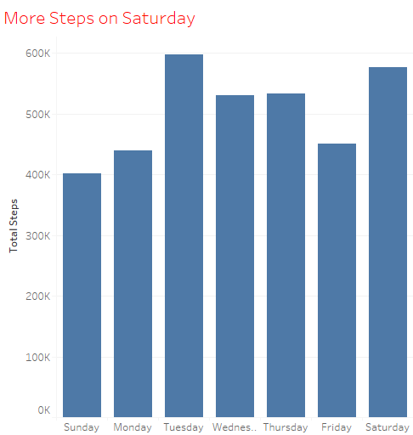 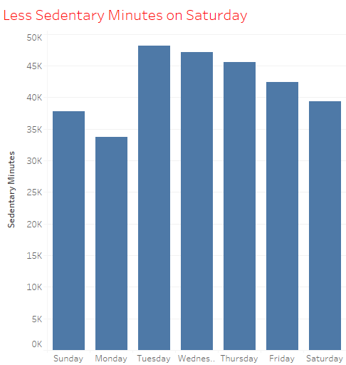

The bar graph shows that there is a jump on Saturday: user spent LESS time in sedentary minutes and take MORE steps. Users are out and about on Saturday.

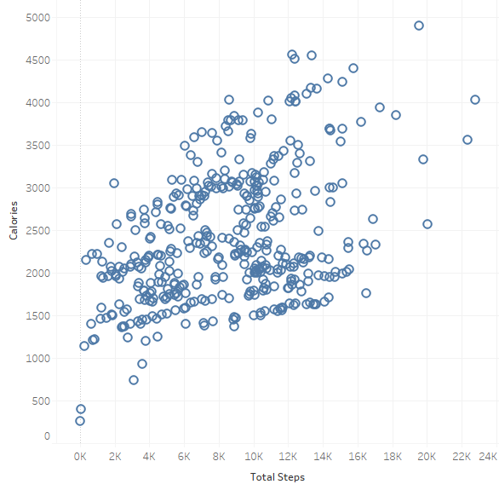

The visualization shows that there is a positive correlation between total steps taken in a day and the calories burn. The more steps we taken, the more calories we burn. The marketing analytics team can position this as a way to motivate users who plan to lose weight to walk more.

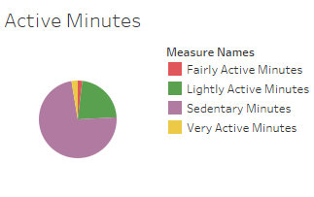

“Sedentary Activity” is the most frequent types of activity carried out by the users; this means that most of the users are working adults who spent long hours sitting in front of the computer/ meeting. The American Heart Association and World Health Organization recommend at least 150 minutes of moderate-intensity activity or 75 minutes of vigorous activity, or a combination of both, each week. That means it needs a daily goal of 21.4 minutes of FairlyActiveMinutes or 10.7 minutes of VeryActiveMinutes.

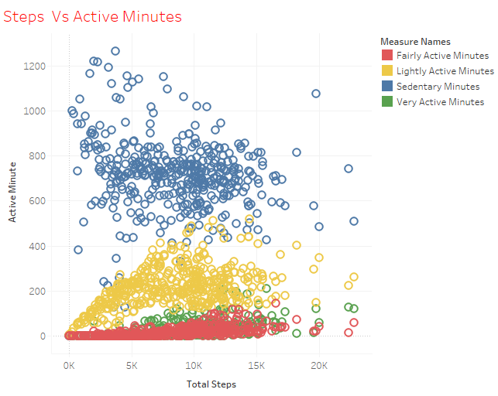

Comparing the four active levels to the total steps, we see most data is concentrated on users who take about 5000 to 15000 steps a day. These users spent an average between 8 to 13 hours in sedentary, 5 hours in lightly active, and 1 to 2 hours for fairly and very active.

According to this healthline.com article, moderately active woman between the ages of 26–50 needs to eat about 2,000 calories per day and moderately active man between the ages of 26–45 needs 2,600 calories per day to maintain his weight. Comparing the four active levels to the calories, we see most data is concentrated on users who burn 2000 to 3000 calories a day. These users also spent an average between 8 to 13 hours in sedentary, 5 hours in lightly active, and 1 to 2 hour for fairly and very active. Additionally, we see that the sedentary line is leveling off toward the end while fairly + very active line is curing back up. This indicate that the users who burn more calories spend less time in sedentary, more time in fairly + active.

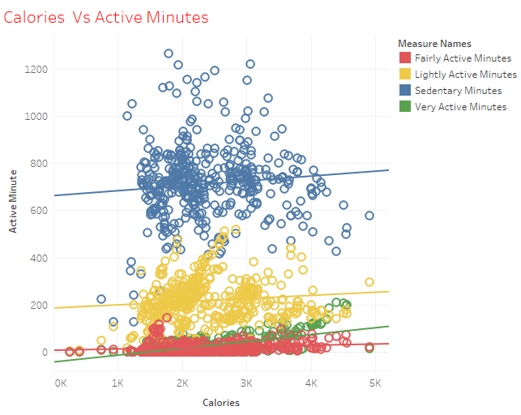

Case Study Roadmap – Act phase:

Business Task: Identify Trends in Smart Device Usage

Target Audience of Bellabeat:

* Female working adults who spent most of the time doing sedentary activities, and rarely exercises.
* Have a relatively good amount of sleep but may spend some time awake in bed.

Given the fact that out of 33 respondents, only 24 of them record sleep data, this means that not every user will wear Bellabeat devices while sleeping.

Reason: • Do not know that Bellabeat app can track sleep data • Do not like wearing Bellabeat devices while sleeping • Do not know the importance of tracking sleep data.

Recommendations for Bellabeat App:

* Educational healthy style campaign encourages users to have short active exercises during the week, longer during the weekends, especially on Sunday where we see the lowest steps and most sedentary minutes.
* Educational healthy style campaign can pair with a point-award incentive system. Users completing the whole week's exercise will receive Bellabeat points on products/memberships.
* The product, such as Leaf wellness tracker, can beat or vibrate after a prolonged period of sedentary minutes, signaling the user it's time to get active! Similarly, it can also remind the user it's time to sleep after sensing a prolonged awake time in bed.
* For users who wants to lose weight, the app can send them notifications to remind these users to do more exercise to burn their calories.